Computational Assignment

CHE 221A

Name: - Bhatt Harshal

Roll No: - 190232

System: - Hydrogen Chloride

Equation of state: - Redlich Kwong

$$P=\left(RT/\left(v-b\right)\right)-\left(a/\left(\sqrt{T}v\left(v+b\right)\right)\right)$$

Algorithm

1. Values of a and b are calculated using Tc and Pc values.
2. PV isotherms are plotted.
3. For plotting linspace function of MATLAB is used which makes an array of values of Molar volume ranging from 0.03 to 3 litres/mol.
4. Corresponding to different volume values, pressure values are obtained.
5. The same above step is repeated for different value Temperatures.

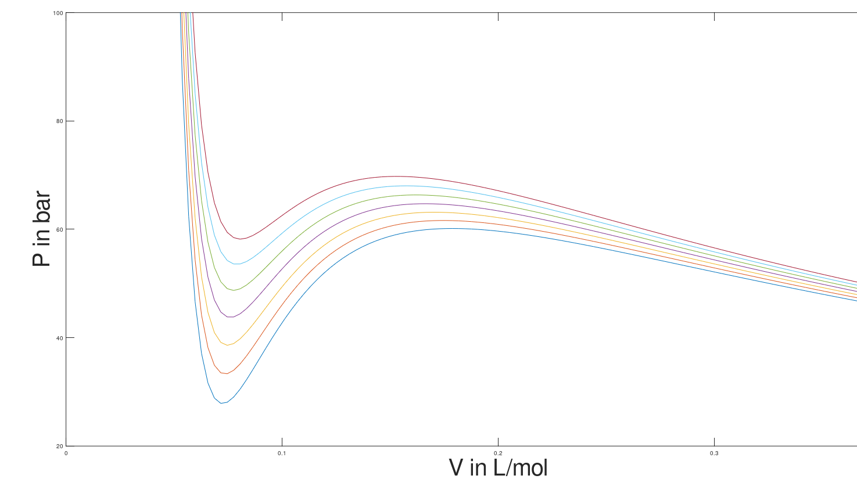

Dome shaped curve

1. A function is created that calculates the root of the cubic equation at different pressure values.
2. Now the cubic equation can have either 3 real roots or 1 real and 2 Imaginary roots.
3. The imaginary roots are eliminated by using “imag(x)” function of MATLAB.
4. Now a loop is used to go over the range of temperatures.
5. Now a guess for Psat values (for temperatures less than 312 Kelvin) is calculated using Antoine equation.
6. Further the guessed pressure values are iterated over another loop by using the False Position Numerical Method considering two cases that are either one real root or 3 real root.
7. Now for temperatures above 312 Kelvin the guess value for Psat is taken by taking the help of previous pressure value (i.e., by adding 2 bars to the previous pressure values)
8. Now for values close to critical temp of 324.7 Kelvin the guess pressure values are estimated by adding 2.5 bars to the previous pressure values.
9. The Psat values are iterated for the condition that chemical potential of liquid phase is equal to chemical potential of gas phase.
10. Polyfit function of 6 degree is used to join the points and the dome curve.

